LDSC

# Environment

## Anaconda

Initialize conda:

source /home1/08005/cz5959/anaconda3/bin/activate

conda init

Activate conda and ldsc env:

conda activate /scratch1/08005/cz5959/ldsc/env

source activate ldsc

# Features

## LD Scores

* For European GWAS, no need to compute own LD scores and can instead use the pre-computed LD scores
  + This will create a eur_w_ld_chr/ directory
  + Computed using 1000 Genomes European data

wget https://data.broadinstitute.org/alkesgroup/LDSCORE/eur_w_ld_chr.tar.bz2

tar -jxvf eur_w_ld_chr.tar.bz2

* Currently, bulik recommends using those same LD scores for both –w-ld-chr and –ref-ld-chr flags for non-partitioned ldsc

## Heritability and Genetic Correlation

<https://github.com/bulik/ldsc/wiki/Heritability-and-Genetic-Correlation>

#### Reformatting Summary Statistics

* Convert your results to .sumstats format using munge_sumstats.py
* Requires following information: rsid; effect allele; non-effect allele; sample size; p-value; signed summary statistic (ex. beta)
* –merge-alleles makes sure that the alleles in your results match the alleles listed in the data used to estimate LD scores
* Check log file for errors with: grep ‘WARNING’ *log



* Reformat Neale Lab to use munge_sumstats.py with
  + Switch signs of betas is A1 != ALT; remove NA



#### Estimating Heritability and LDSC Intercept

* LDSC – get heritability and intercept



# Results

#### Heritability and Intercept of Single Phenotype

|  |  |  |  |  |  |  |  |
| --- | --- | --- | --- | --- | --- | --- | --- |
| GWAS | | My LDSC | | LDSC Neale | | Actual Neale | |
| Phenotype | **Sex** | **Heritability** | **Intercept** | **Heritability** | **Intercept** | **Heritability** | **Intercept** |
| Height | Both | 0.419 | 1.6768 | 0.423 | 0.485 | 0.485 | 1.313 |
| Female | 0.4298 | 1.3777 |  |  |  |  |
| Male | 0.434 | 1.309 |  |  |  |  |
| Testosterone | Both | 0.0815 | 1.0731 | 0.0889 | 1.0464 | 0.0771 | 1.062 |
| Female | 0.0506 | 1.0385 |  |  |  |  |
| Male | 0.166 | 1.0725 |  |  |  |  |
| BMI | Both | 0.2275 | 1.2145 | 0.2276 | 1.1172 | 0.248 | 1.105 |
| Female | 0.2422 | 1.0961 |  |  |  |  |
| Male | 0.2563 | 1.0774 |  |  |  |  |
| IGF-1 | Both | 0.1987 | 1.2771 | 0.201 | 1.1818 | 0.253 | 1.125 |
| Female | 0.2032 | 1.1672 |  |  |  |  |
| Male | 0.2382 | 1.1193 |  |  |  |  |
| Total  Bilirubin | Both | 0.0786 | 1.0891 | 0.0835 | 1.036 | 0.543 | 0.77 |
| Female | 0.0944 | 1.056 |  |  |  |  |
| Male | 0.0942 | 1.0458 |  |  |  |  |
| Creatinine | Both | 0.0954 | 1.1313 | 0.1022 | 1.0757 | 0.211 | 1.093 |
| Female | 0.1264 | 1.0819 |  |  |  |  |
| Male | 0.0909 | 1.0629 |  |  |  |  |
| RBC Count | Both | 0.1839 | 1.3098 |  |  | 0.234 | 1.156 |
| Female | 0.2026 | 1.1803 |  |  |  |  |
| Male | 0.1831 | 1.1162 |  |  |  |  |

#### Correlation Between Male and Female

|  |  |  |  |  |  |
| --- | --- | --- | --- | --- | --- |
|  | Correlation | | | | |
| Phenotype | **Genetic** | **Baseline Enrichments** | **Cell Type Enrichments** | **Cahoy** | **GTEx Brain** |
| Height | 0.9723 | 0.979 | 0.981 | 0.999 | 0.985 |
| Testosterone | 0.0156 | 0.805 | 0.812 | 0.959 | 0.490 |
| BMI | 0.9272 | 0.970 | 0.952 | 0.999 | 0.893 |
| IGF-1 | 0.8919 | 0.942 | 0.982 | 0.998 | 0.950 |
| Total Bilirubin | 0.9815 | 0.848 | 0.989 | 0.997 | 0.762 |
| Creatinine | 0.897 | 0.867 | 0.996 | 0.844 | 0.953 |
| RBC Count | 0.951 | 0.977 | 0.997 | 0.999 | 0.757 |

# Log

### 6/10/2021

* Set up environment by downloading anaconda for linux <https://github.com/bulik/ldsc#readme>
* Neale Lab Header



* + Neale doesn’t have rsid included; I can try to match with plink2 results
* Plink2 Header



### 6/11/2021

* Download LD scores and alleles used to compute LD scores
* Create sumstats file format from results



### 6/14/2021

* Calculate heritability and ldsc intercept for height
* Error: IndexError while reading LD Scores
  + Forgot to add the “/” after eur_w_ld_chr
* H2 and intercept for height
  + What is lamda and ratio
  + Lambda: percent variance in dependent variable (height) not explained by difference differences in levels of independent variable (genotype)
  + Ratio: Ratio is (intercept-1)/(mean(chi^2)-1), which measures the proportion of the inflation in the mean chi^2 that the LD Score regression intercept ascribes to causes other than polygenic heritability.

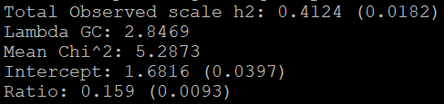

### 6/15/2021

* Format Neale lab to be suitable for munge_py
  + Download variants file



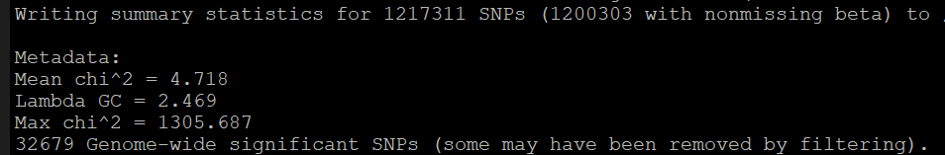

* H2 and intercept for Height from Neale Results

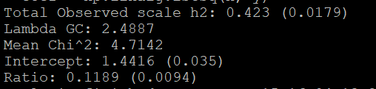

### 6/16/2021

* GC bias: genomic region of a higher GC content tends to have more (or less) Illumina reads covering that region
* Intercept, mean chi square when tagging 0 casual SNPs
* GC bias
  + Recombination: get errors one sis as GC; other sis has AT; should both have GC
    - Heteroduplex gets repaired, repairs more GC because stronger bond
  + Will see more GC in areas of higher recombination rates
* Neale Lab for height: heritability = 0.485 ; intercept = 1.313

6/17/2021

* Updates height (AX as non-effect), both sex

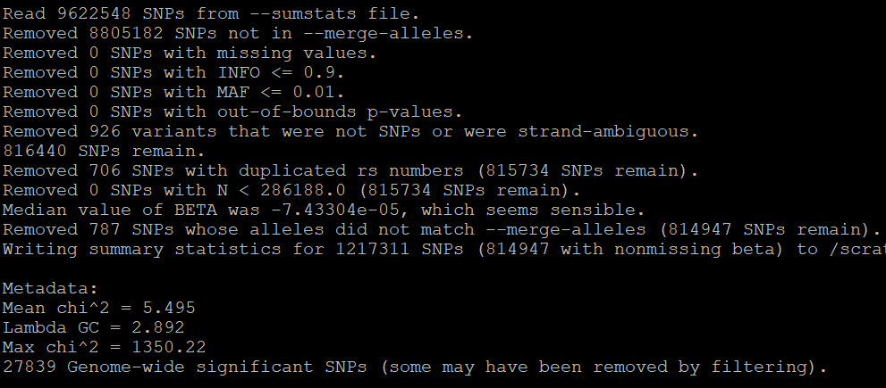

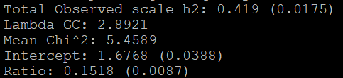

* Female

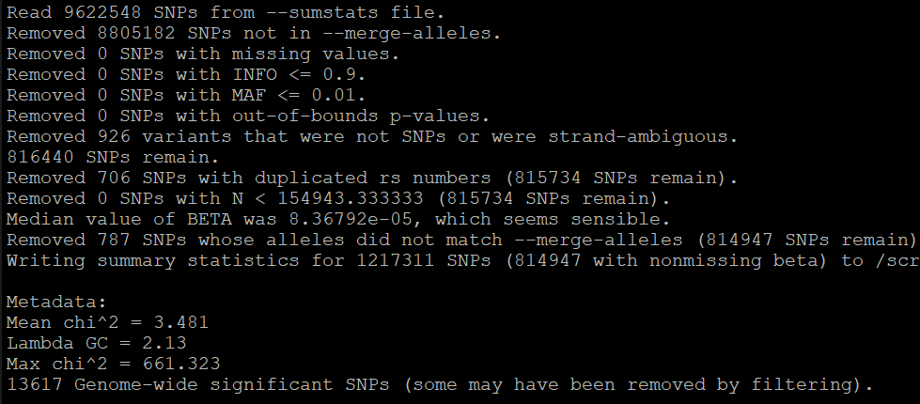

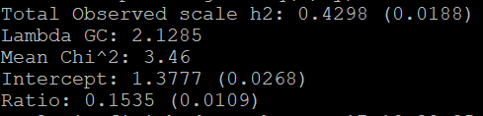

* Male

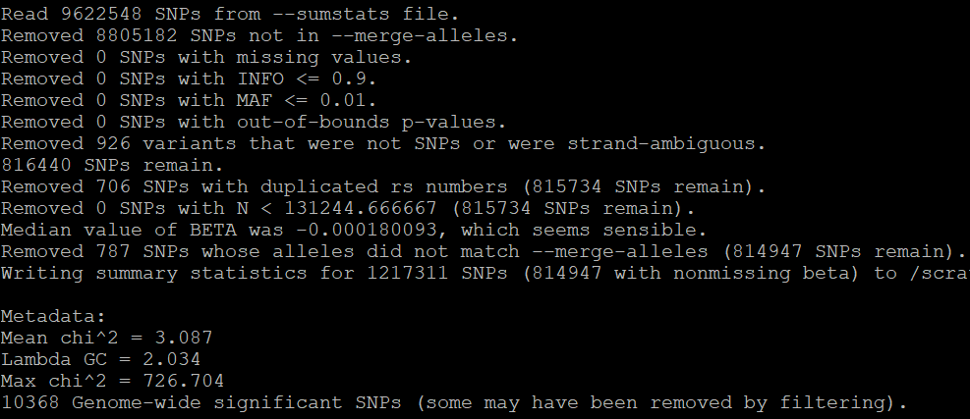

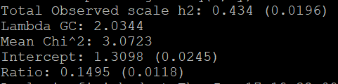

### 6/21/2021

* Get ldsc h2 and intercept for testosterone and BMI
* Write code for partitioned heritability

### 6/24/2021

* Couldn’t run code on total bilirubin since the results file contained p-values that were too small to be converted to numeric

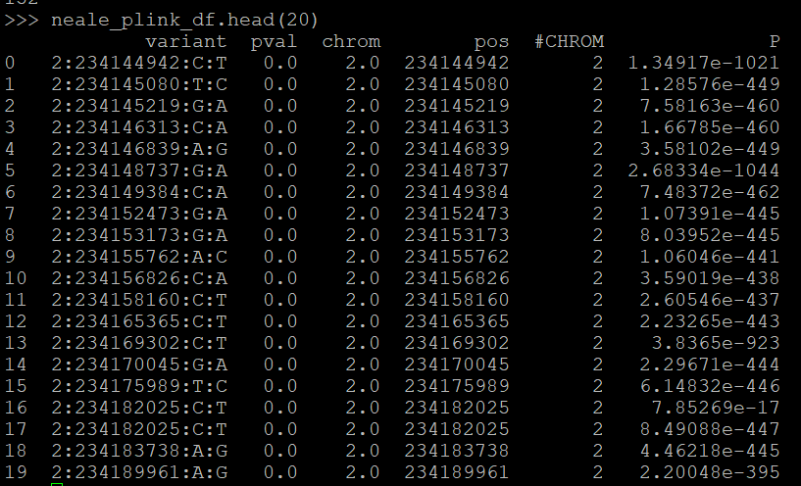

* Create a format_plink script to get rid of rows with p-values that can’t be converted
  + Reformat for bilirubin and RBC
* Get ldsc for Neale Lab IGF1 to examine my results and their results
  + Reformat script for Neale Lab Manhattan plot and format_neale
  + My plink and my neale more similar than actual neale
  + They could be using a different code?
* Bar chart for partitioned heritability
  + Enrichment = proportion heritability / proportion SNPs

### 6/30/2021

* Negative heritability~~: individuals with similar genotypes likely to have more divergent trait values than those with differing genotypes~~  estimated heritability is less than expected
* Enrichment: estimated share of heritability the category contributes divided by its expected share

Baseline Functional Categories

* Coding region: base sequence identical to mRNA transcript produced
* Conserved: identical/sim sequences across species
* CTCF: CCCTC-binding factor; highly conserved zinc finger protein, transcription factor
* DGF-1: dispersed gene family 1
* DHS: DNase I hypersensitive sites; regions of chromatin that are sensitive to cleavage by DNase I enzyme
* Enhancer: promote transcription
* FetalDHS
* H3k27ac: epigenetic modification to histone H3, acetylation, active enhancer mark
* H3k27me3: epigenetic modification to histone H3, methylation, downregulation
* TFBS: transcription factor binding sites
* TSS: transcription start site
* UTR 3’ and 5’: untranslated region on each side of mRNA

Testosterone Correlation

* Mine: 0.0156 sex-specific GWAS paper: 0.120
* GWAS of 3 traits:

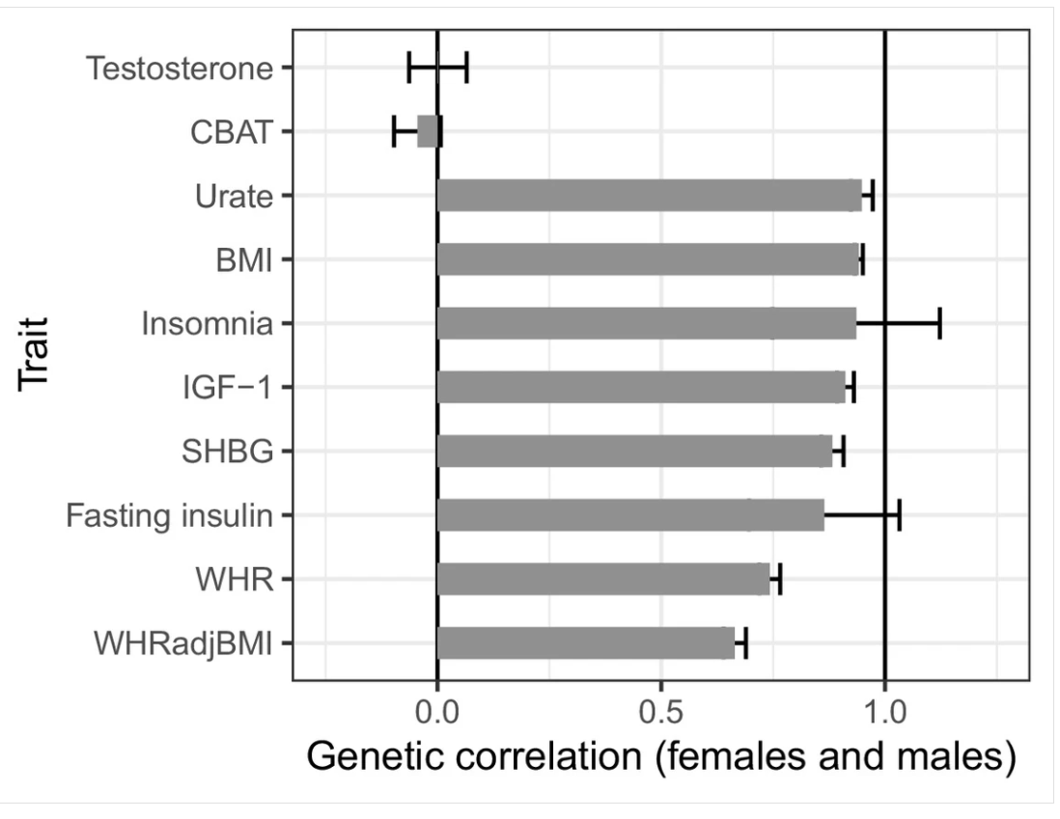

### 7/1/2021

List of Cell Type Groups

* Adrenal_Pancreas; Cardiovascular; CNS; Connective_Bone; GI; Immune; Kidney; Liver; SkeletalMuscle; Other
* Code for cell type partitioned heritability

### 7/5/2021

* SEMM calculation of correlation seem to be higher than reference?

### 7/7/2021

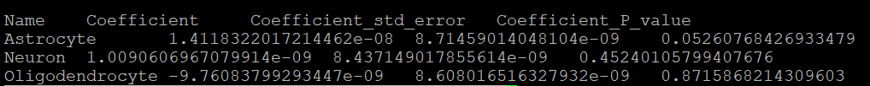

* Cell type partitioned heritability
  + Move cell type LD scores to ldsc folder
  + Coefficient: estimate of first regression coefficient

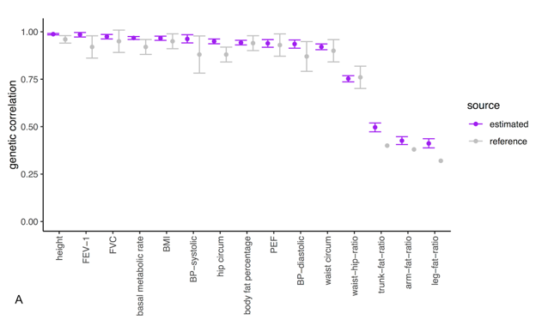

* Cell type partition results

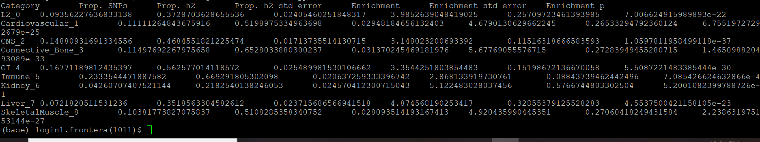

* Correlation among cell type and baseline annotations
* Create plots for cell-type with error bars

# Code

### LDSC and Partitioned LDSC





### Format Neale



### Format Plink



### Bar Chart – Partitioned Heritability

